# List all customers from India

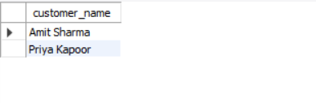

# Show all products priced above $100, ordered by price descending

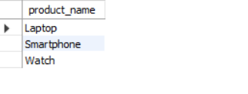

# Find the total quantity of each product sold.

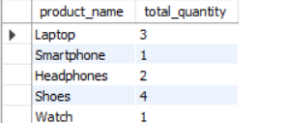

# Get all orders placed after August 2, 2025.

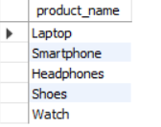

# Show customer name, product name, and quantity for each order (INNER JOIN).

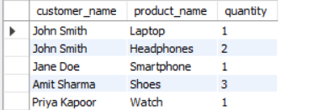

# List all customers and the products they ordered (LEFT JOIN).

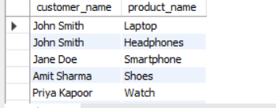

# List all products and customers who ordered them (RIGHT JOIN).

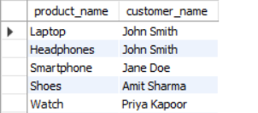

# Find products that have a price higher than the average product price.

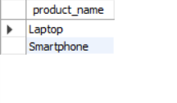

# Get the customer(s) who ordered the most expensive product.

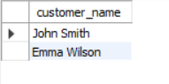

# Find the total sales (price × quantity) for each category.

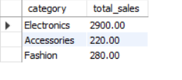

# Get the average price of products in the "Accessories" category.

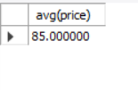

# Create a view that shows customer_name, product_name, quantity, and total_price.



# Create an index on the Orders table for order_date to improve date range queries.

